Timesheet Contactor

# Installation

## Install the .NET Framework

In order to use the application, you must install the .NET Framework. To do so, please follow this link <https://dotnet.microsoft.com/download/dotnet-framework/net48> and click on the button which says “Download .NET Framework 4.8 Runtime”. The button to click is shown below:

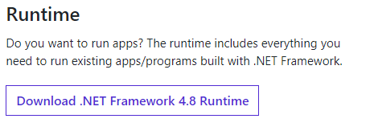

## Install the Application

Please download the zip file containing the application from <https://github.com/nickmunch/TimesheetContactor> You can do this by following these steps:

1. Click the button which says code:

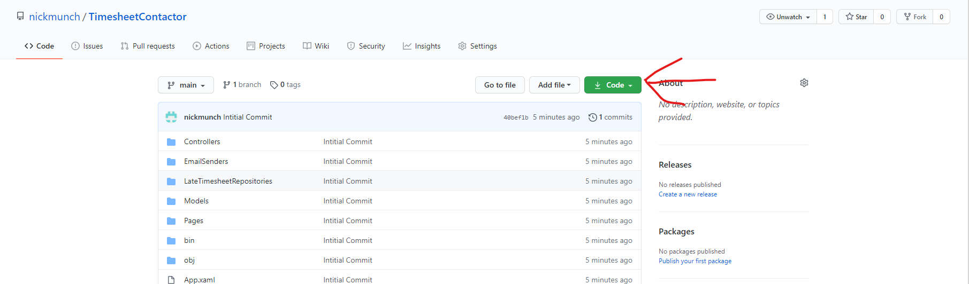

1. Click Download ZIP

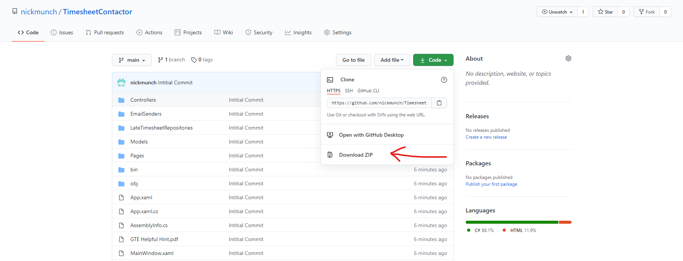

1. Unzip the file
2. The Timesheet Contactor application can be found in {Location you unzipped at}\TimesheetContactor-main\bin\Release\net48\WPFLateTimesheetsApp.exe
3. Should you want to move the program elsewhere, you must move the entire net48 folder, not just the exe file.

# Requirements

## Outlook

This application uses Outlook to send out all emails, so it requires that the user have outlook installed and that they are logged in to the account in Outlook from which they would like to send the emails.

## Excel

In order to create the Tab-Separated files that are used as input, the user will need Excel.

## Required Files

The application requires the files emailOpening.html and emailClosing.html be present within the same Directory as the program itself.

# Expected Input Format

The program expects the input file to have the following format in terms of required columns and their order:



The input file is required to be a Tab-Separated file (.txt).

To create a tab separated file from an excel file, follow the following steps:

1. Ensure you are on the worksheet containing the timesheet info. Select “File” from the Toolbar: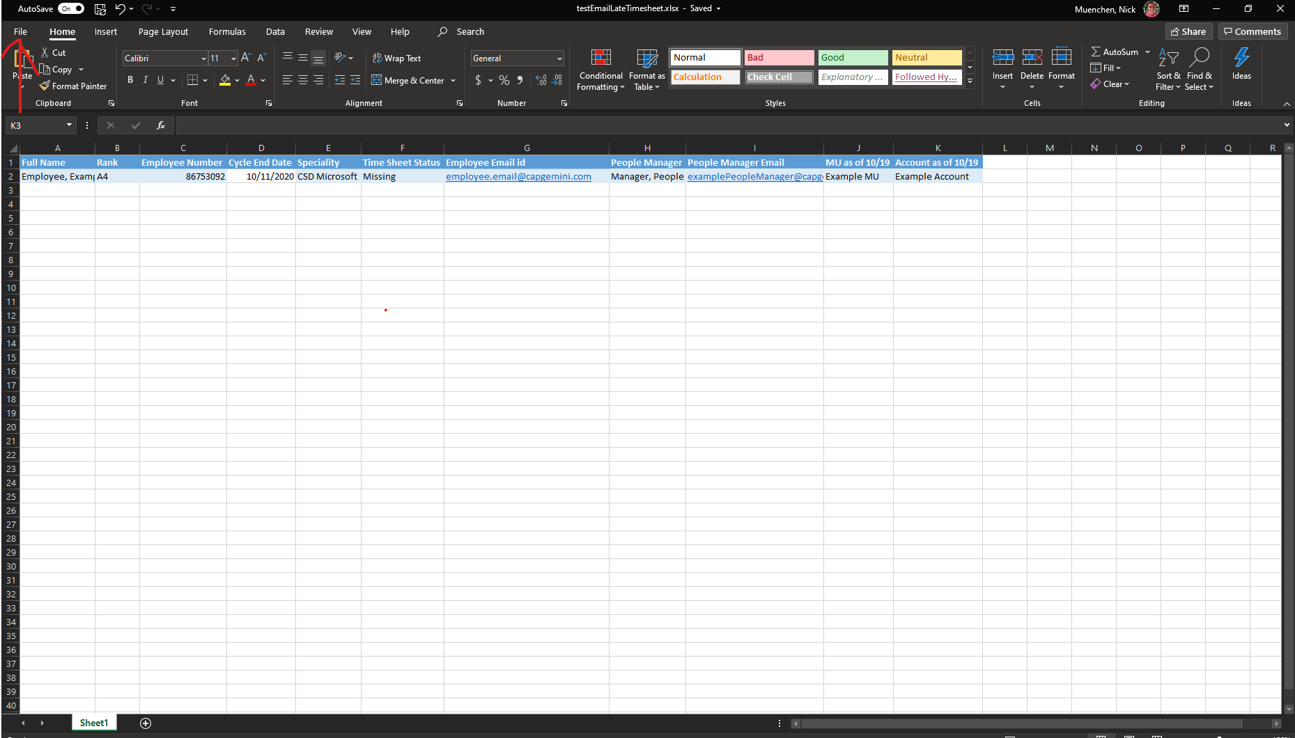
2. Select “Save A Copy”

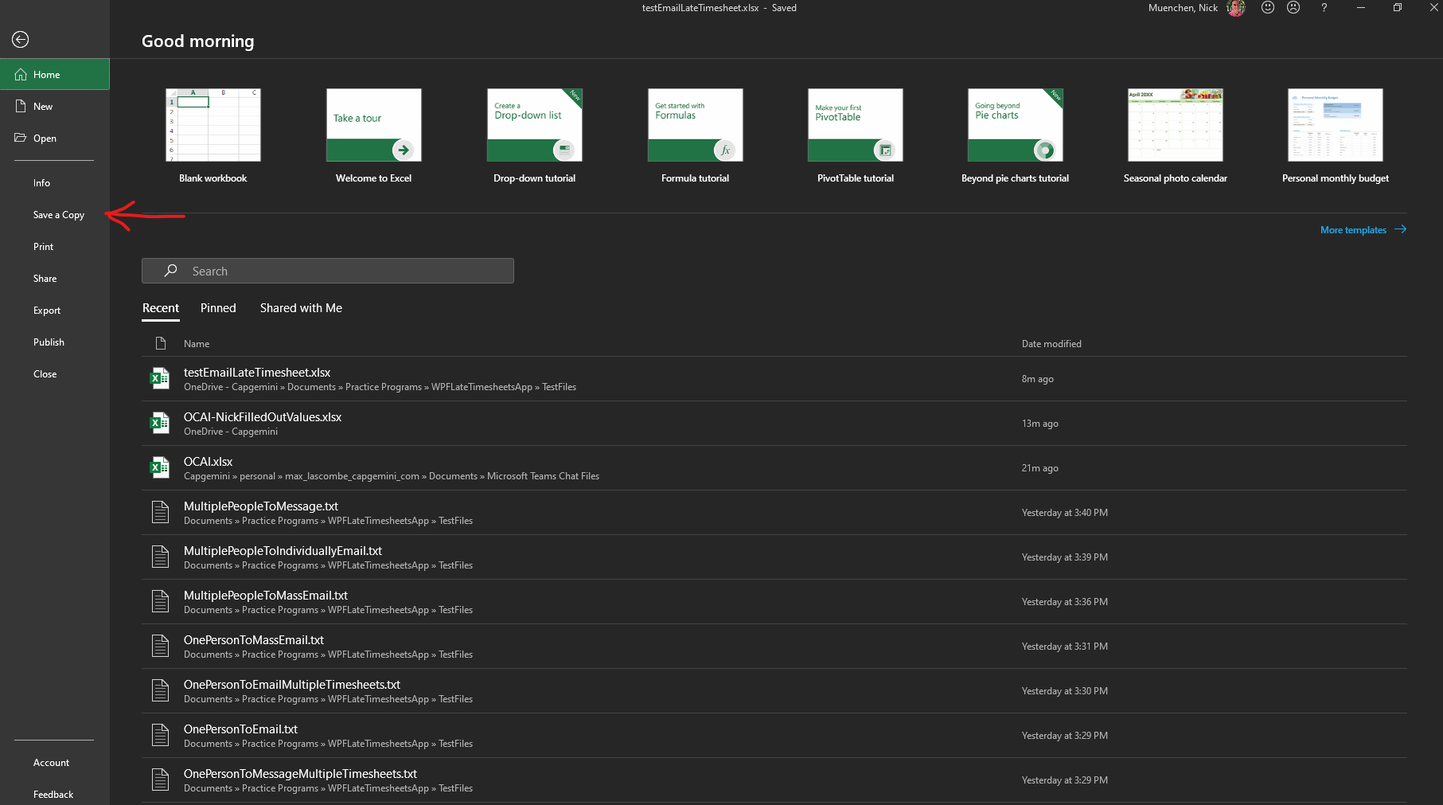

1. Select the File Format Dropdown

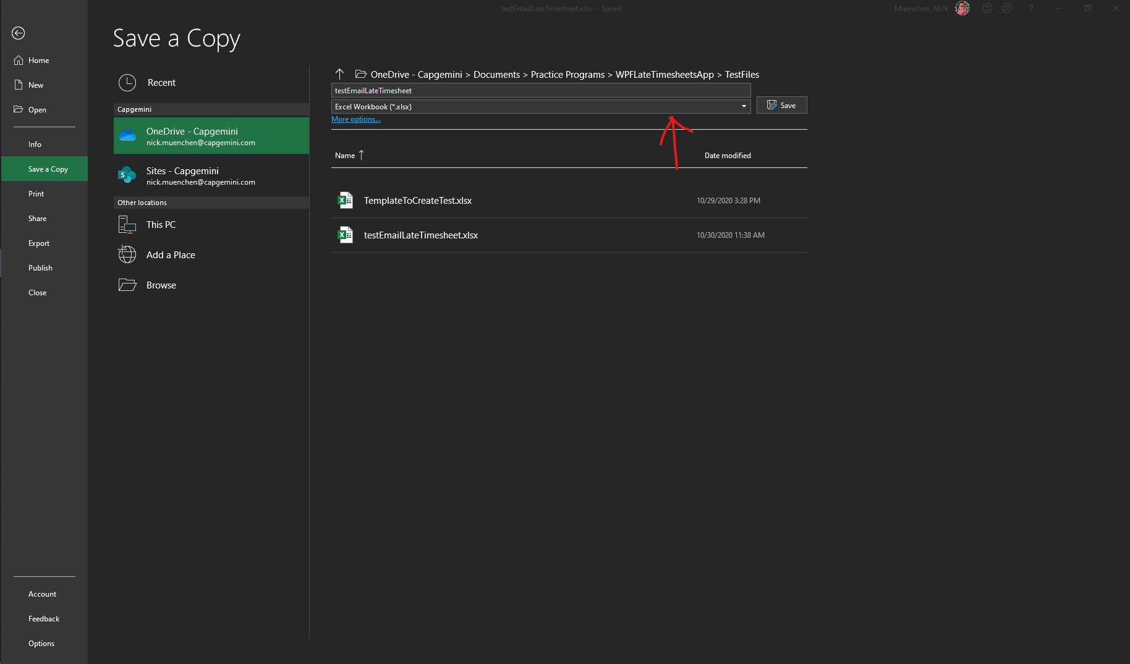

1. Choose the option “Text (Tab delimited) (*.txt)”

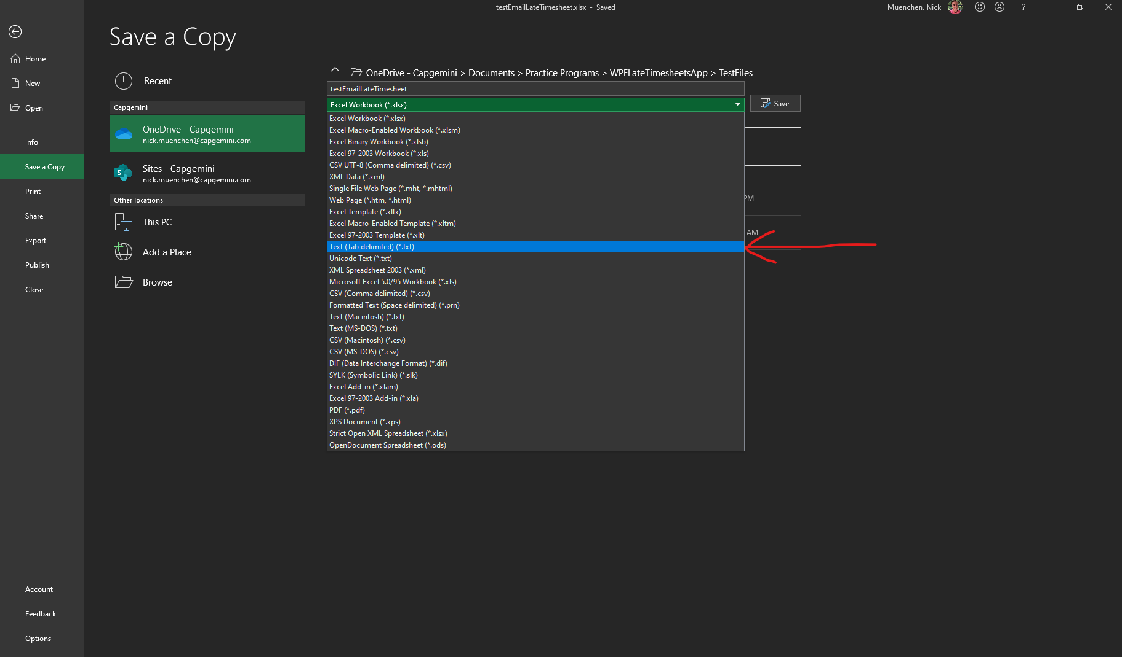

1. Click “Save”, then close the file.

# Usage Guide

## Start the Program

To run the program, double click on “WPFLateTimesheetsApp.exe” within the folder {Location you unzipped at}\TimesheetContactor-main\bin\Release\net48\WPFLateTimesheetsApp.exe

## Using the Program

After starting the program up, the user needs to fill out each of the fields listed on the screen:

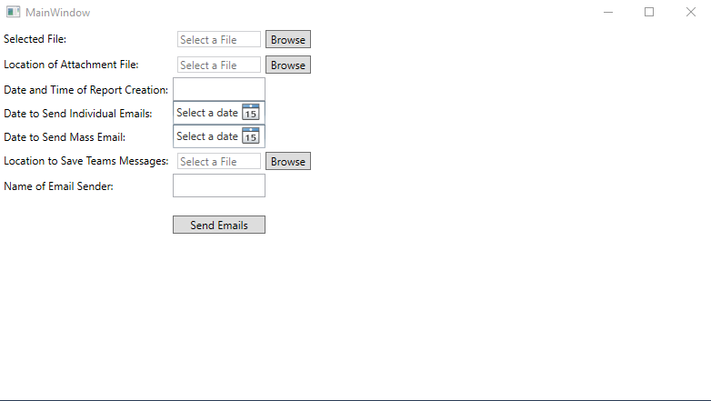

The fields are:

* **Selected file**: This is the input file which contains the timesheet information.
* **Location of the attachment file:** This is the location of the “GTE Helpful Hint.pdf” file which will be attached to the email.
* **Date and Time of Report Creation:** This field should be used to put in the time that the report was generated. This is included in the email that is sent out. The preferred format is: “26-Oct 2020, 6:00 PM EST”.
* **Date to Send Individual Emails:** This is the date on which the program will begin to send out individual emails to people with late timesheets. Any employees with missing timesheets before this date will have a Teams message generated for them.
* **Date to Send Mass Email:** This is the timesheet cycle date for which the program will include employees on the bulk email. Timesheet cycle dates after this date are ignored. Late timesheets for cycle dates before this date will either receive individual emails or have a Teams message generated for them.
* **Location to Save Teams Messages:** This is the file where any generated Teams messages will be saved. Teams Messages are generated for all employees with a timesheet missing from before the “Date to Send Individual Emails”. If there are no Teams messages to send, then the file will not be updated or created. Please type the name of the file that you would like to save them to into the bar at the bottom of file explorer or select a file which already exists.
* **Name of Email Sender:** This is the name of the person whose email will be used to send the messages. It is used to create a signature/sign off at the end of the emails. For example, if the name Bruce Wayne was used, then the emails would end with:

Thank you,

Bruce Wayne

After filling out the fields, simply hit the “Send Emails” button. Any emails that need to be sent out will be delivered and any Teams messages that need to be sent will be created and saved to the file that you designated. If no Teams messages needed to be created, then the file either won’t be changed or won’t be created.

# Example Output

## Example Teams Messages File

The following is an example of the output that could be found in the Teams messages output file. These messages would need to be copied and sent to the relevant user after they were generated.

Messaging "Duck, Donald"

Hello,

According to a report generated with data pulled from Test, you are missing your timesheet(s) for the following week end dates. Please submit your timesheet ASAP and let me know when this is complete.

Name: "Duck, Donald"

Missing Timesheet: 10/4/2020 12:00:00 AM

Status of Timesheet: Missing

Name: "Duck, Donald"

Missing Timesheet: 10/11/2020 12:00:00 AM

Status of Timesheet: Missing

Name: "Duck, Donald"

Missing Timesheet: 10/18/2020 12:00:00 AM

Status of Timesheet: Missing

Name: "Duck, Donald"

Missing Timesheet: 10/25/2020 12:00:00 AM

Status of Timesheet: Missing

Please make sure to "Submit" the timesheet and not just "Save".

Thank you

Nick Muenchen

------------------------------------------------------------

Messaging "Potter, Harry"

Hello,

According to a report generated with data pulled from Test, you are missing your timesheet(s) for the following week end dates. Please submit your timesheet ASAP and let me know when this is complete.

Name: "Potter, Harry"

Missing Timesheet: 10/11/2020 12:00:00 AM

Status of Timesheet: Missing

Name: "Potter, Harry"

Missing Timesheet: 10/25/2020 12:00:00 AM

Status of Timesheet: Missing

Please make sure to "Submit" the timesheet and not just "Save".

Thank you

Nick Muenchen

## Example Individual Email

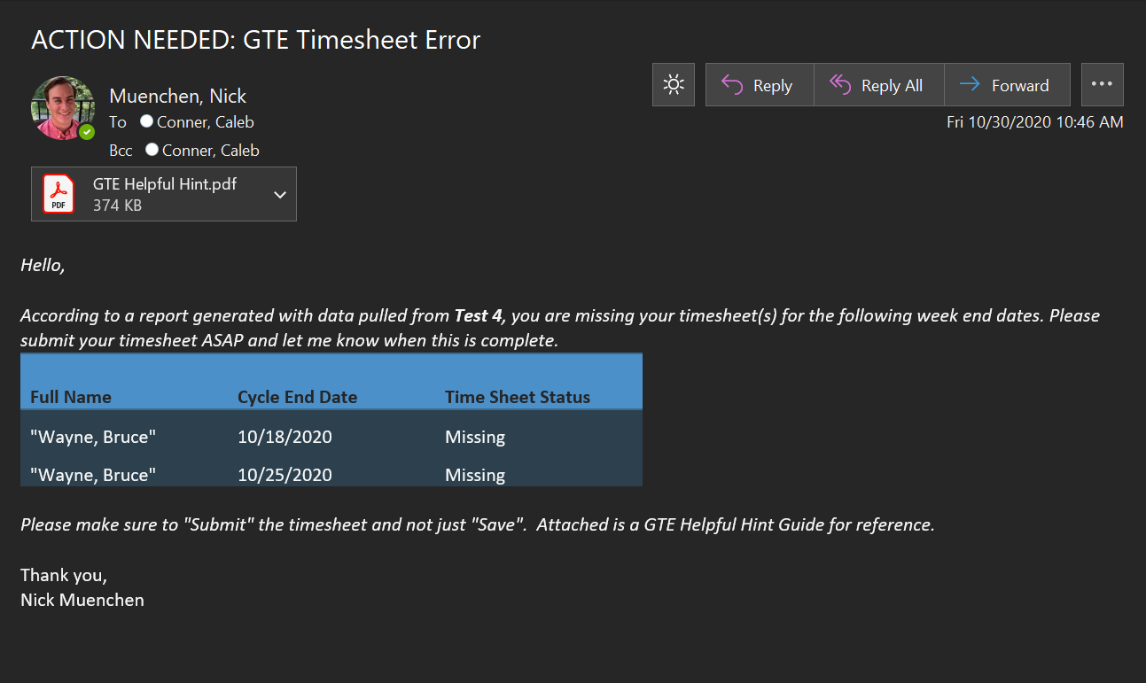

## Example Mass Email

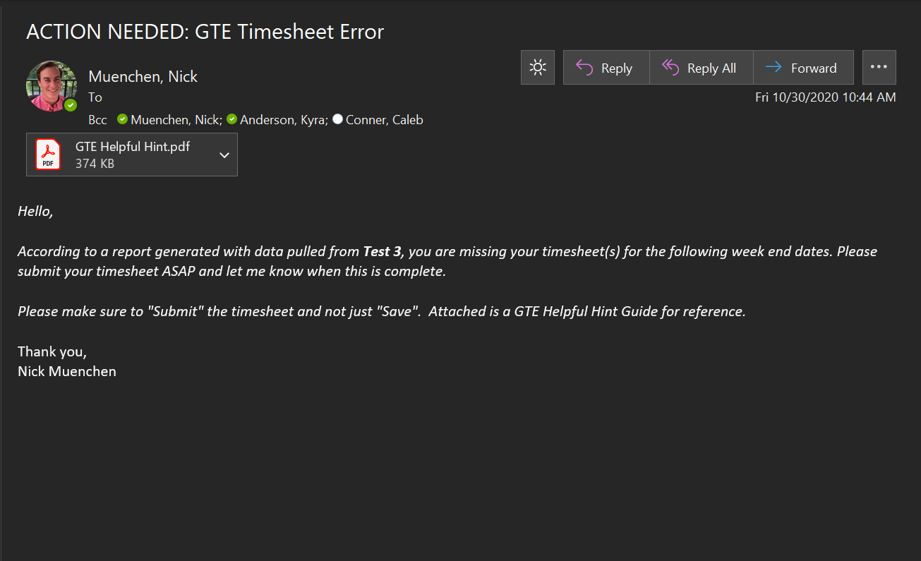

# Errors

If all necessary input is provided to the application and there are still errors occurring, feel free to contact me at [nick.muenchen@capgemini.com](mailto:nick.muenchen@capgemini.com) or by sending a Teams Message to Muenchen, Nick. I will offer any help I can in getting things to work again.